Tips for a Successful Year
- Be kind to your classmates and teachers.

- Participate in class, and always show how smart you are.

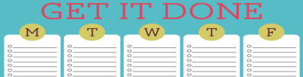
- Stay organized, always have a pencil (or 25 cents to buy one), and have a method in place to keep track of homework and upcoming due dates.
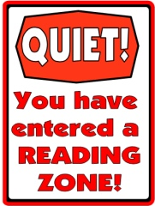
- Bring your novel to class EVERY DAY! Begin reading as soon as you enter the classroom.
  - Monday – Thursday we read the first 10 minutes of class.
  - Friday we read all period.

- Choose books that are just right for you, and read at home.
  - 560 pages Quarter 1 (approximately 60 pages each week)
  - 620 pages Quarter 2 (approximately 70 pages each week)
  - 740 pages Quarter 3 (approximately 80 pages each week)
  - 740 pages Quarter 4 (approximately 80 pages each week)
- See me the day you return from an absence to find out what you missed.

- See me before your music lesson to find out what you will be missing.

- Love your Chromebook! Treat it with respect and keep it charged.
- Keep your headphones in your locker. If I see them, I take them.
- Snacks allowed on Friday during independent reading. Water only in 214.

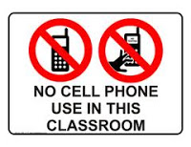
- Keep your cell phone in your locker. If I see it, I take it.

